Week 12 Assignment

By

Ujjwal Bhasin 200389272

Relational Databases

Maziar Shazari

Step 0:

CREATE DATABASE Week12;

USE Week12;

CREATE TABLE my_conatct

LIKE `week_11_assignment`.my_contacts;

USE Week12;

DROP TABLE my_conatct;

USE week12;

CREATE TABLE my_contacts

LIKE `week_11_assignment`.my_contacts;

DESC my_contacts;

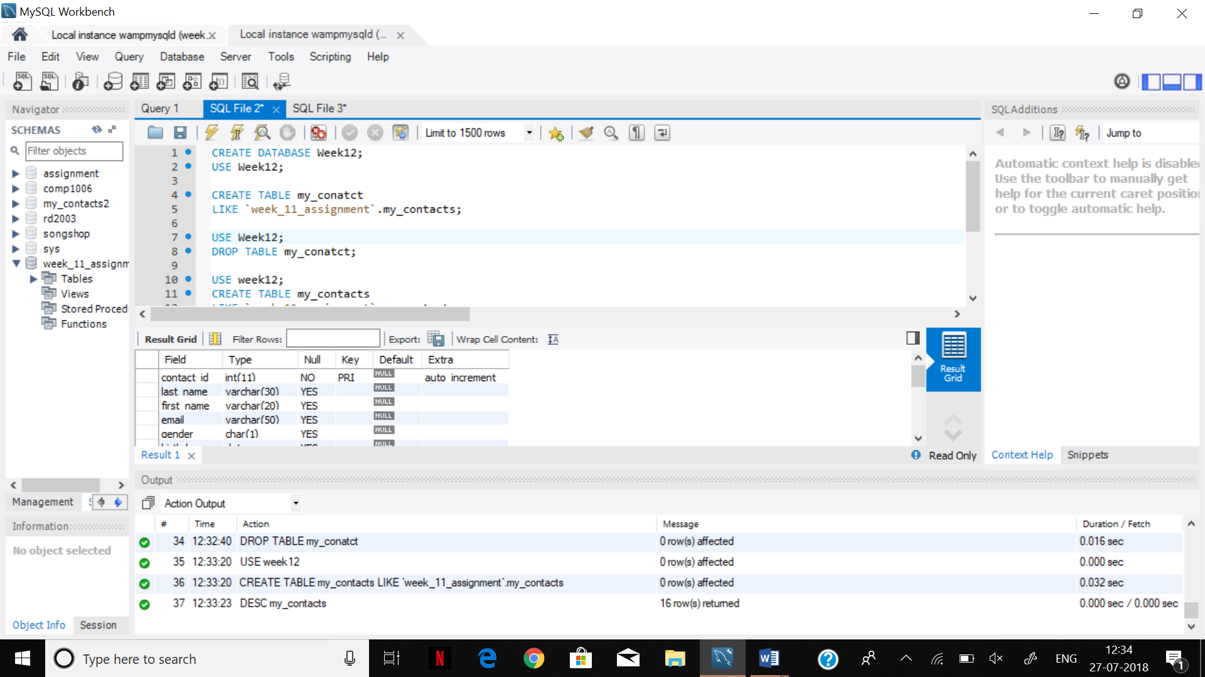

Step 1.

SELECT * FROM my_contacts;

INSERT INTO my_contacts

SELECT * FROM

week_11_assignment.my_contacts;

SELECT * FROM my_contacts;

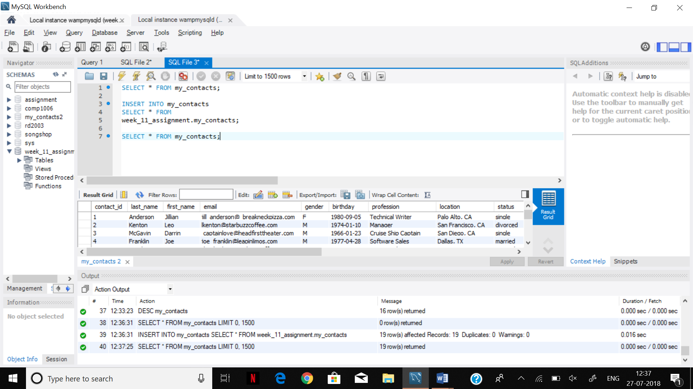

Step 2.

CREATE TABLE Profession LIKE week_11_assignment.my_contacts;

CREATE TABLE job_current

(

contact_ID int auto_increment primary key not null,

title nvarchar (30),

salary double (12,2),

start_date date,

foreign key (contact_ID) references my_contacts(contact_ID)

);

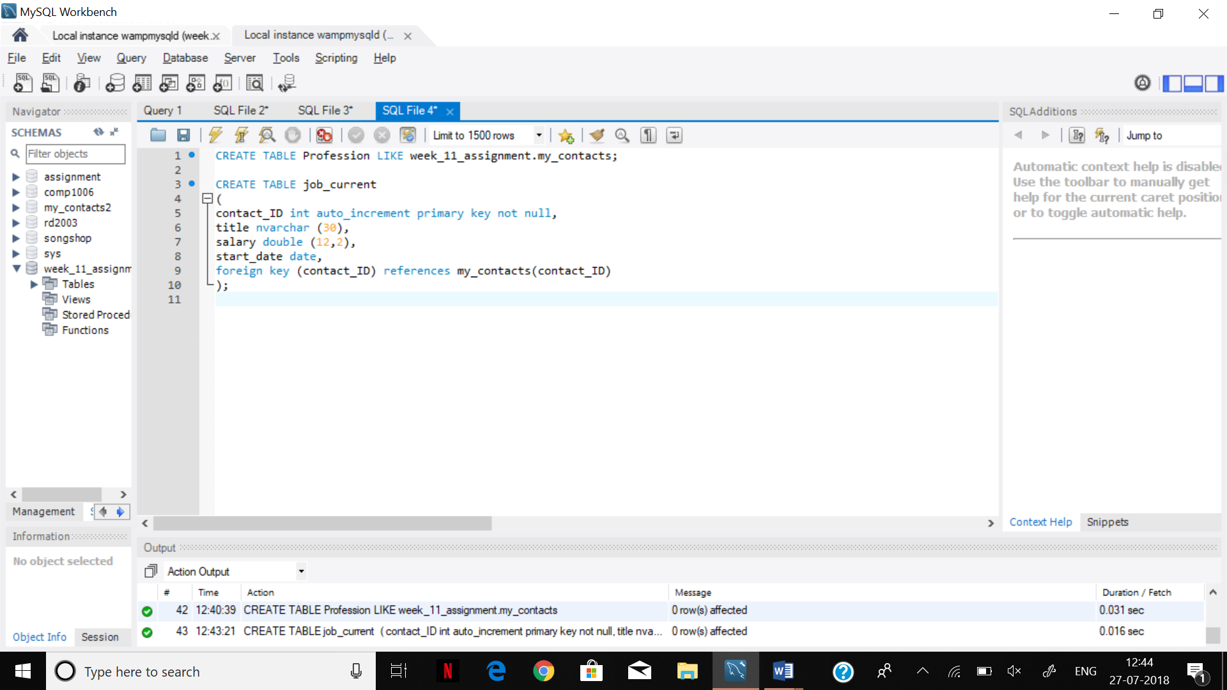

Step 3.

INSERT INTO `week12`.`job_current` (`contact_ID`, `title`, `salary`, `start_date`) VALUES ('1', 'Author', '85000.00', '2002-01-06');

INSERT INTO `week12`.`job_current` (`contact_ID`, `title`, `salary`, `start_date`) VALUES ('2', 'Manager', '120000.00', '1999-05-01');

INSERT INTO `week12`.`job_current` (`contact_ID`, `title`, `salary`, `start_date`) VALUES ('3', 'Boat Captain', '95400.00', '2002-02-02');

INSERT INTO `week12`.`job_current` (`contact_ID`, `title`, `salary`, `start_date`) VALUES ('4', 'Saleman', '55000.00', '2017-04-04');

INSERT INTO `week12`.`job_current` (`contact_ID`, `title`, `salary`, `start_date`) VALUES ('5', 'System Administrator', '73000.00', '2014-04-01');

INSERT INTO `week12`.`job_current` (`contact_ID`, `title`, `salary`, `start_date`) VALUES ('6', 'Stock Market Trader', '180000.00', '2011-05-01');

INSERT INTO `week12`.`job_current` (`contact_ID`, `title`, `salary`, `start_date`) VALUES ('7', 'Unemployed', '0.00', 'null');

INSERT INTO `week12`.`job_current` (`contact_ID`, `title`, `salary`, `start_date`) VALUES ('8', 'Administrator', '82000.00', '2011-01-01');

INSERT INTO `week12`.`job_current` (`contact_ID`, `title`, `salary`, `start_date`) VALUES ('9', 'Software Programmer', '78000.00', '2016-01-05');

INSERT INTO `week12`.`job_current` (`contact_ID`, `title`, `salary`, `start_date`) VALUES ('10', 'Salesman', '68000.00', '2015-05-07');

INSERT INTO `week12`.`job_current` (`contact_ID`, `title`, `salary`, `start_date`) VALUES ('11', 'Chef', '68000.00', '2017-01-05');

INSERT INTO `week12`.`job_current` (`contact_ID`, `title`, `salary`, `start_date`) VALUES ('12', 'Baker', '51000.00', '2014-08-01');

INSERT INTO `week12`.`job_current` (`contact_ID`, `title`, `salary`, `start_date`) VALUES ('13', 'Teacher', '85000.00', '1998-05-01');

INSERT INTO `week12`.`job_current` (`contact_ID`, `title`, `salary`, `start_date`) VALUES ('14', 'Cashier', '42000.00', '2018-01-07');

INSERT INTO `week12`.`job_current` (`contact_ID`, `title`, `salary`, `start_date`) VALUES ('15', 'Application Designer', '75000.00', '2013-01-07');

INSERT INTO `week12`.`job_current` (`contact_ID`, `title`, `salary`, `start_date`) VALUES ('16', 'Programmer', '110000.00', '2012-08-08');

INSERT INTO `week12`.`job_current` (`contact_ID`, `title`, `salary`, `start_date`) VALUES ('17', 'Programmer', '89000.00', '1999-07-30');

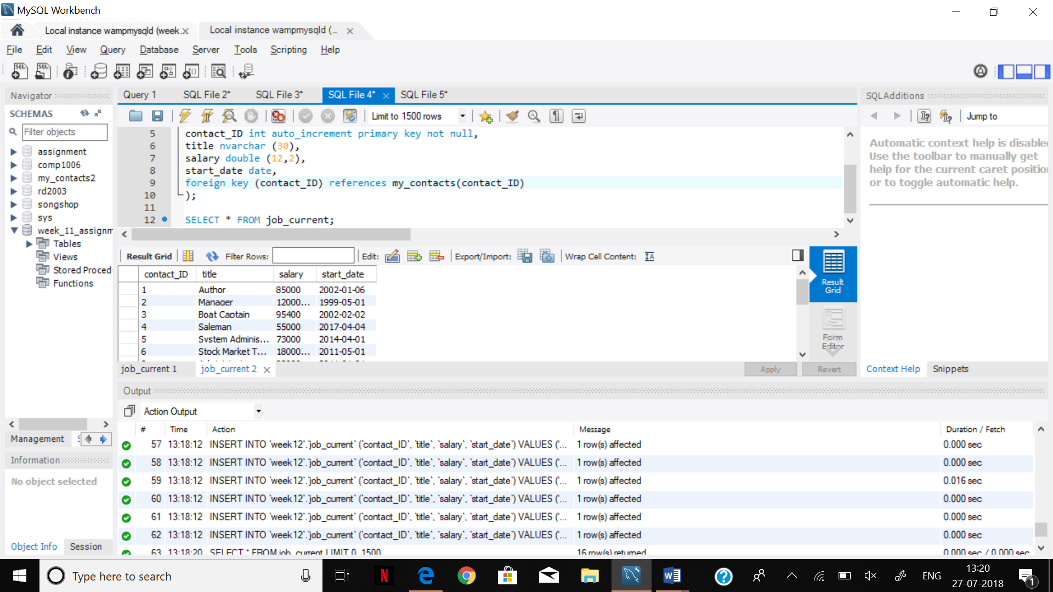

Step 4.

SELECT mc.*,jc.*

FROM my_contacts AS mc

NATURAL JOIN

job_current AS jc;

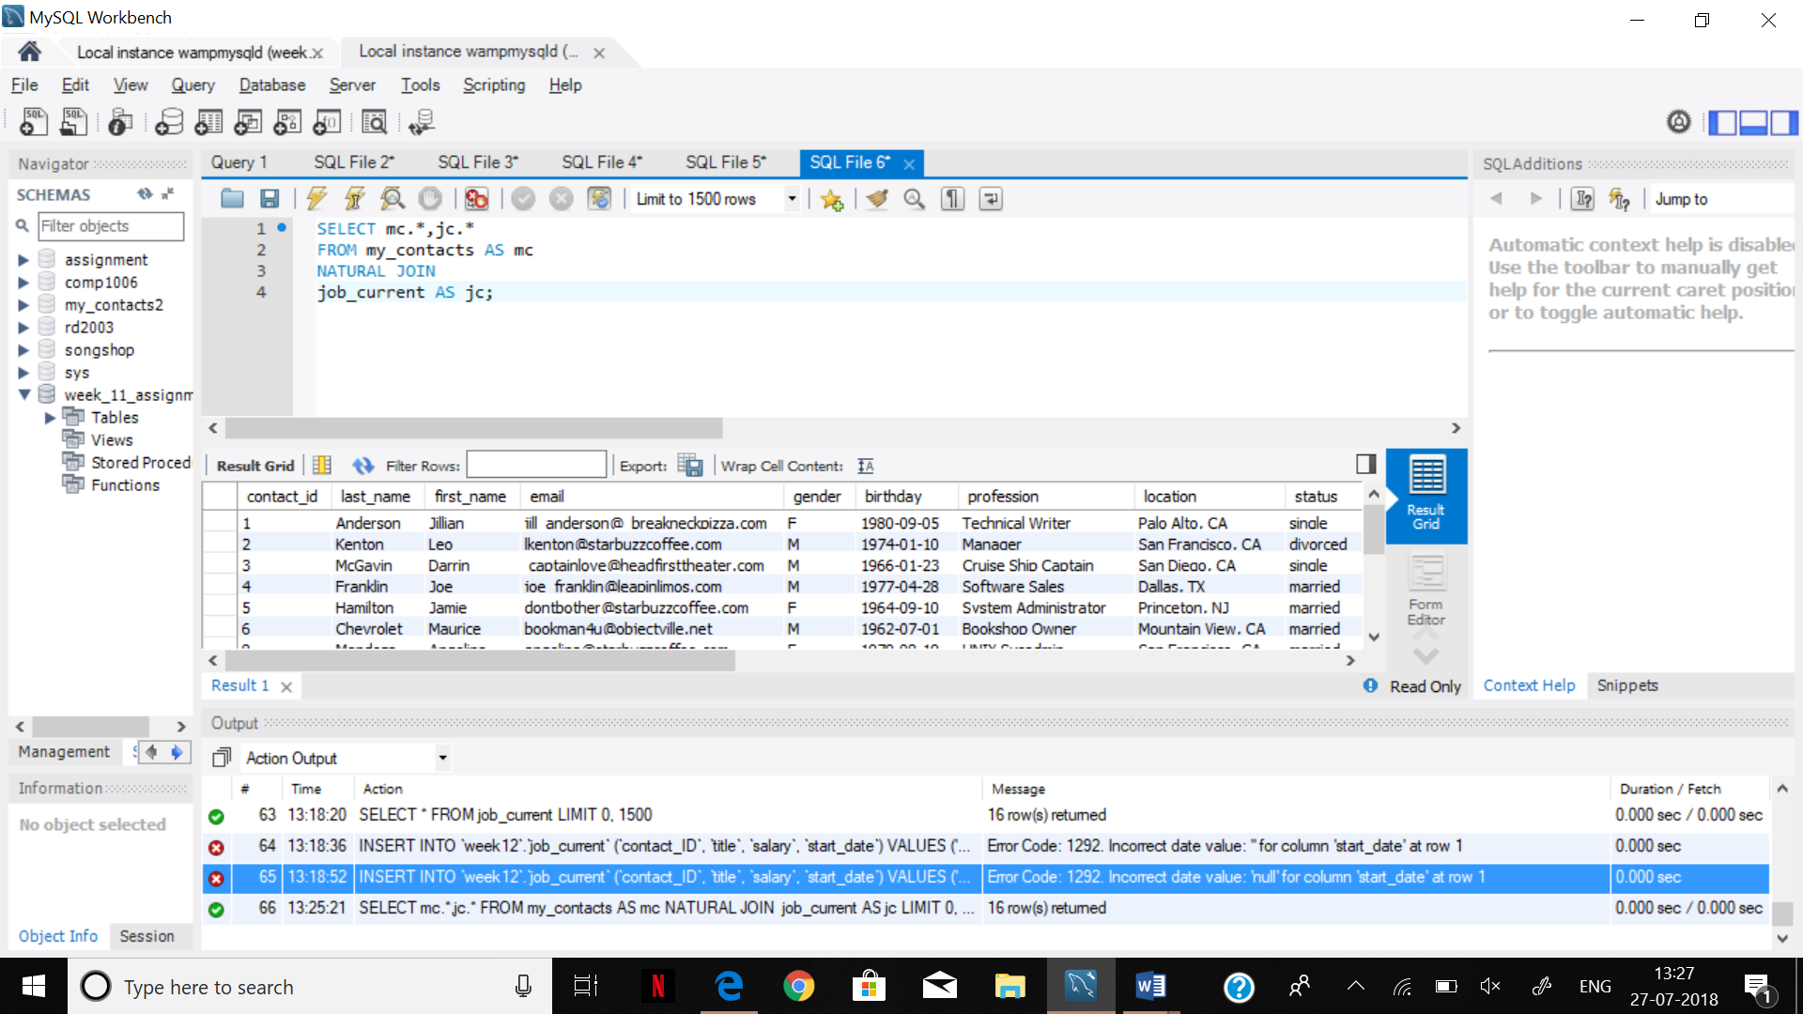

SELECT

mc.contact_id, mc.first_name, jc.salary, jc.title

from my_contacts AS mc

NATURAL JOIN

job_current AS jc;

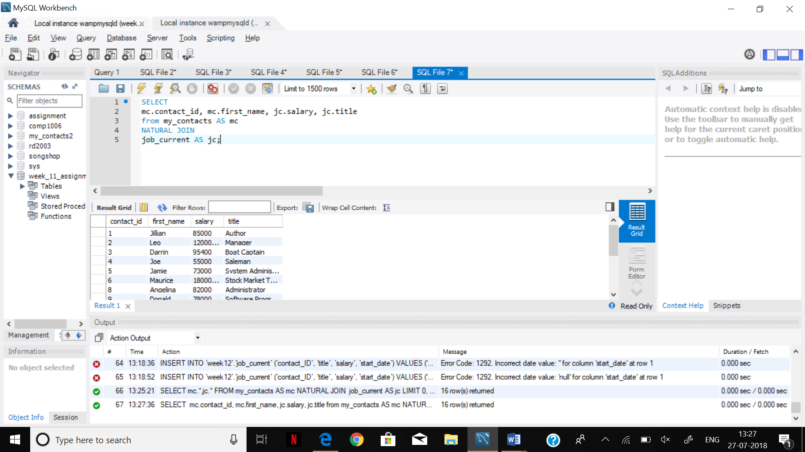

SELECT mc.contact_id, mc.first_name,jc.salary,jc.title

FROM my_contacts As mc

JOIN

job_current as jc

ON mc.contact_id = jc.contact_ID;

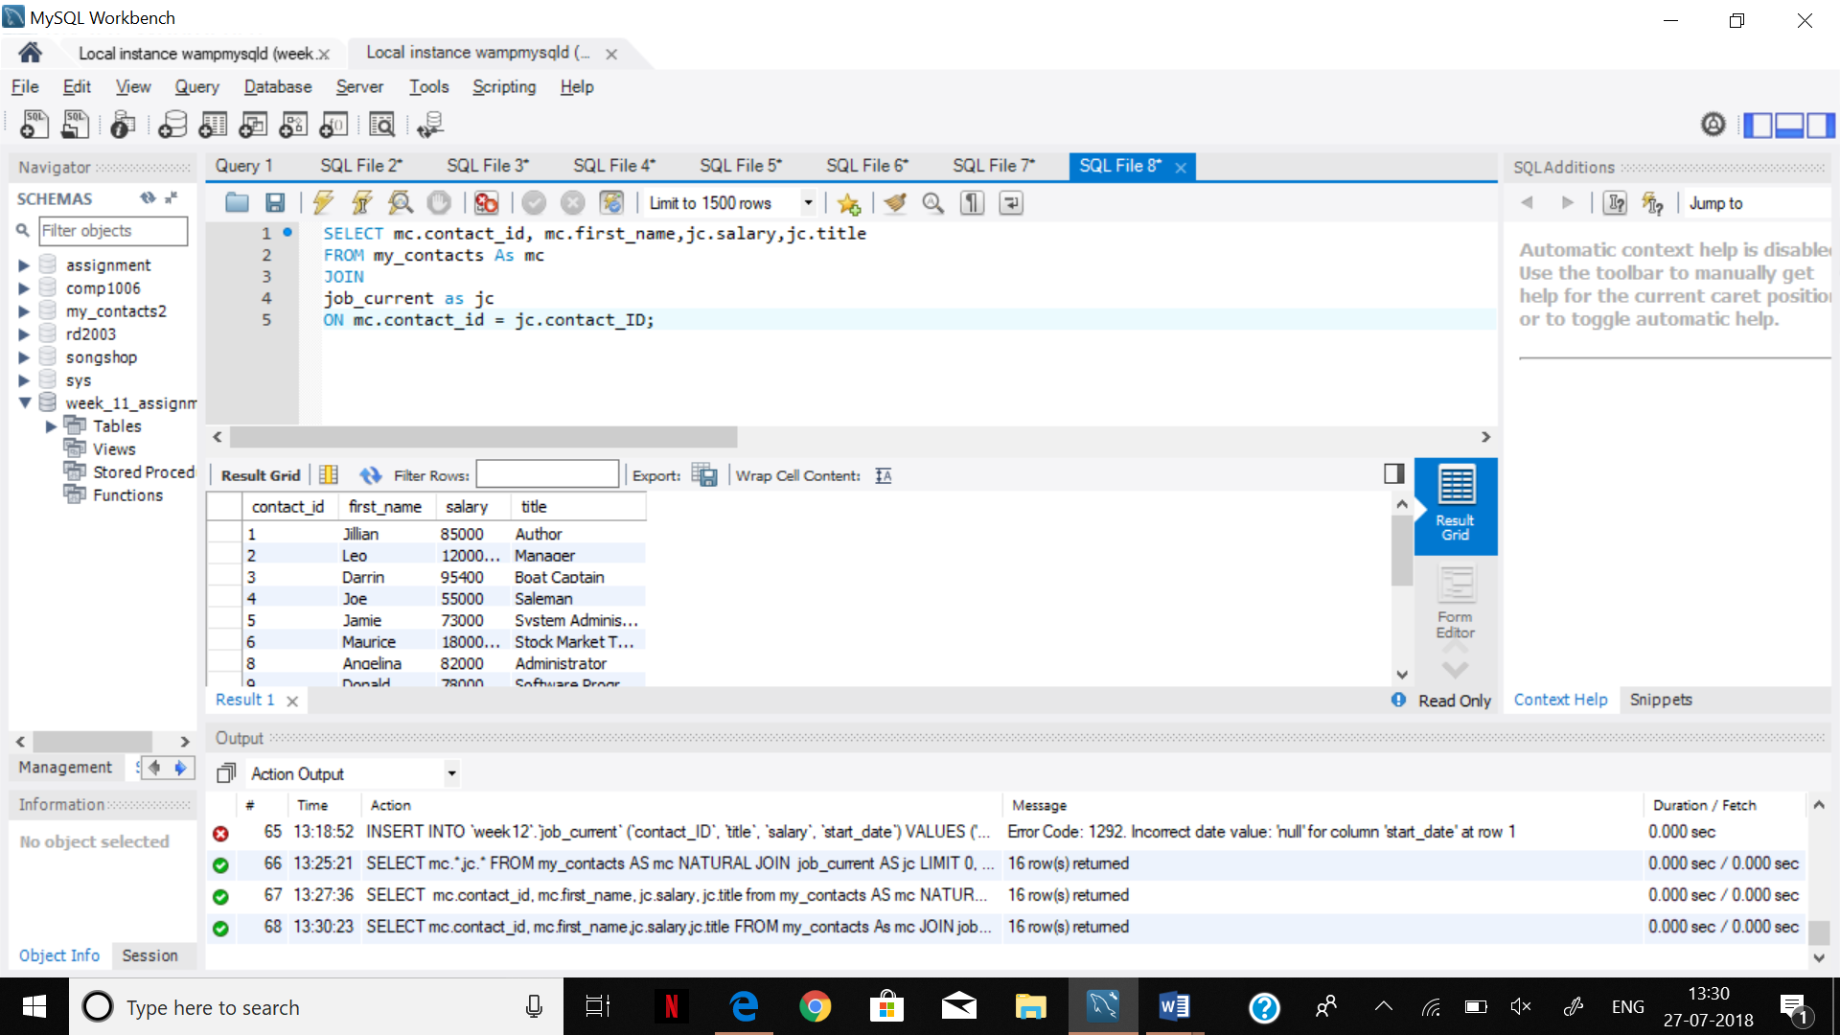

SELECT mc.contact_id,mc.first_name,jc.salary,jc.title

FROM my_contacts as mc

INNER JOIN

job_current as jc

ON mc.contact_id = jc.contact_ID;

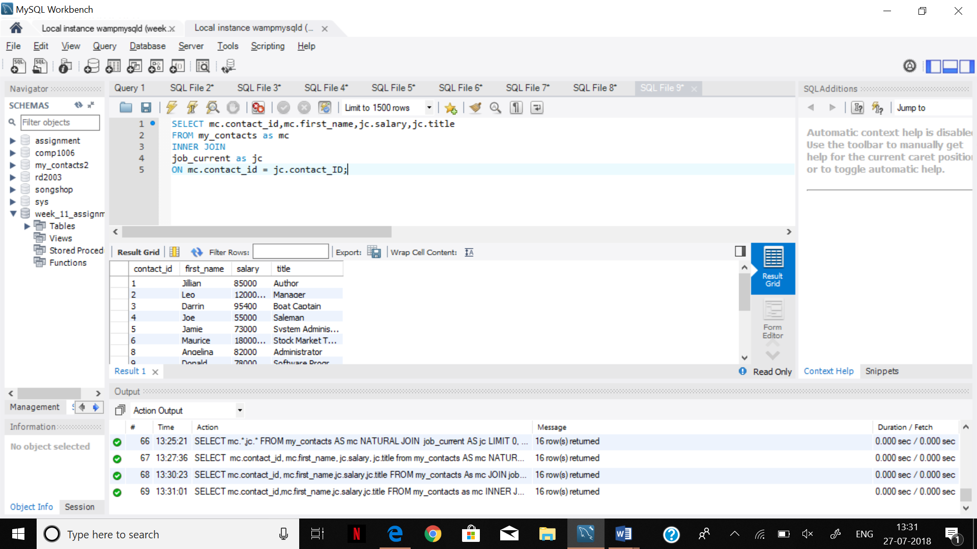

Step 5.

SELECT mc.contact_id, mc.first_name, jc.salary, jc.title

FROM my_contacts AS mc

NATURAL JOIN

job_current AS jc

WHERE salary > 80000;

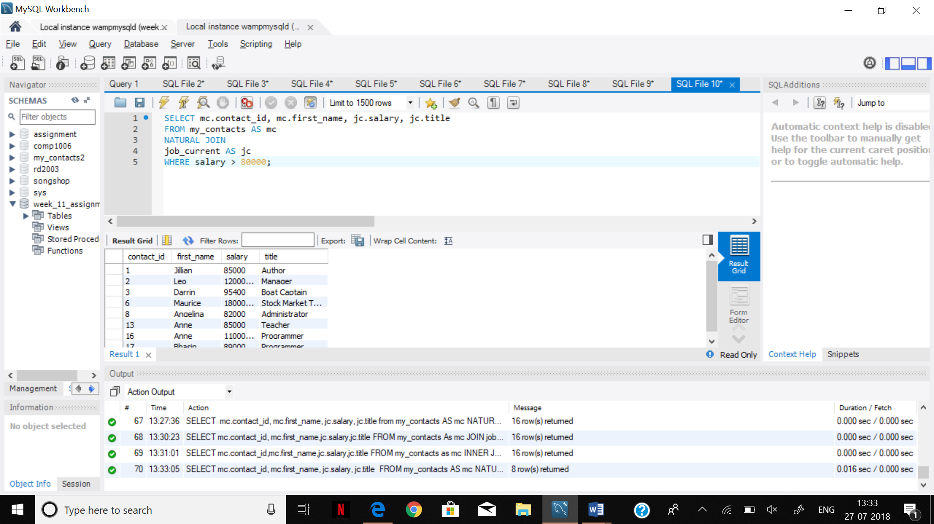

SELECT mc.contact_id, mc.first_name, jc.salary, jc.title

FROM my_contacts AS mc

NATURAL JOIN

job_current AS jc

WHERE salary > 80000

ORDER BY salary DESC;

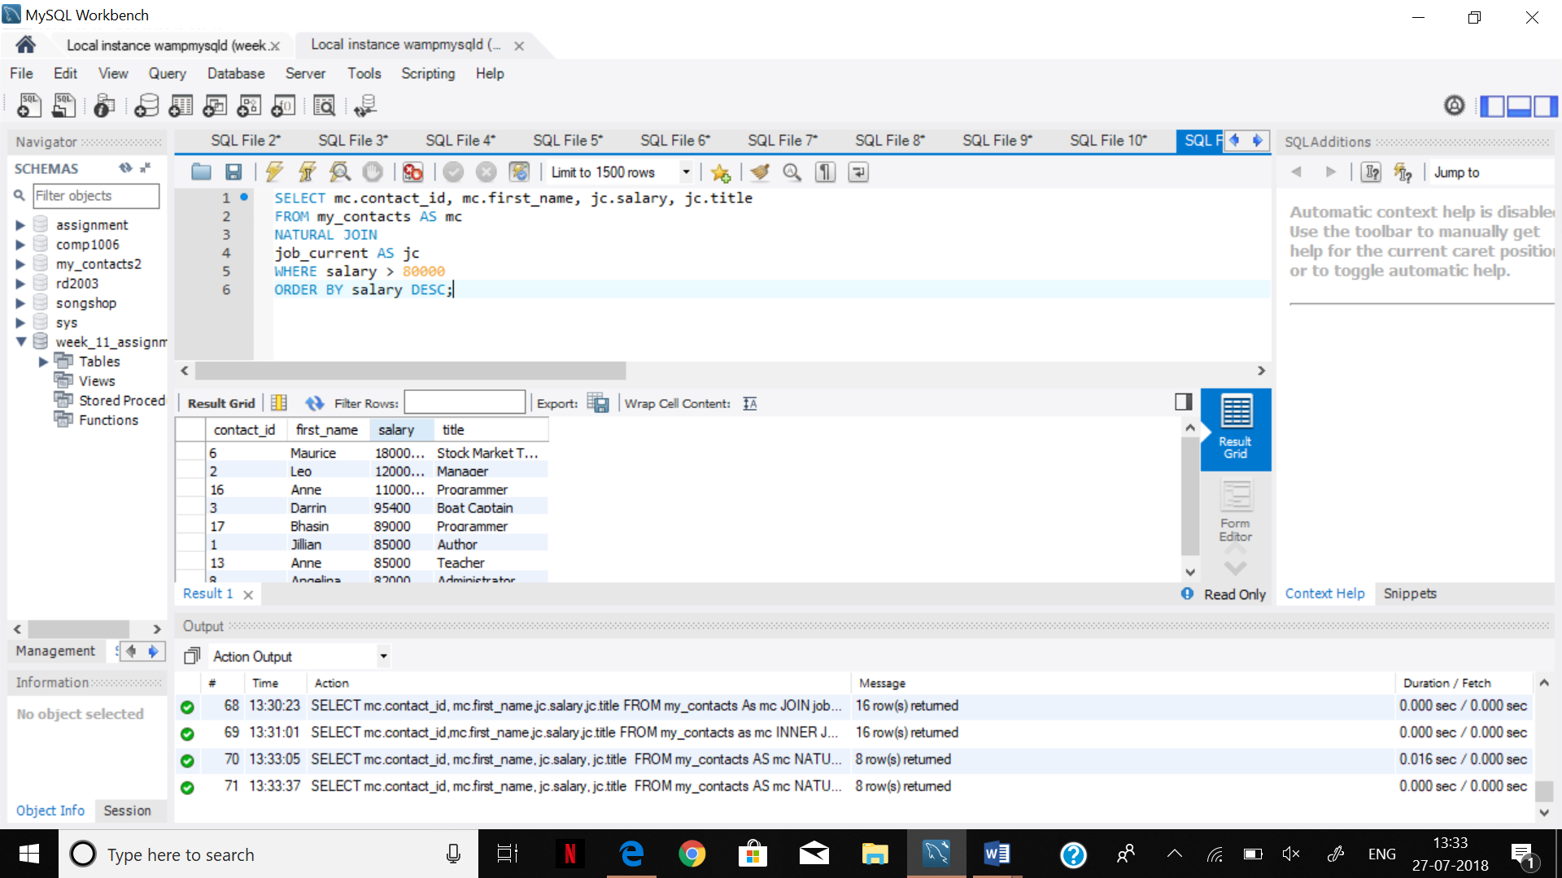

Step 6.

SELECT mc.contact_id AS ID, mc.first_name AS Name, jc.salary AS Salary, jc.title AS Title

FROM my_contacts AS MC

NATURAL JOIN

job_current AS JC

WHERE SALARY > 80000

ORDER BY salary DESC;

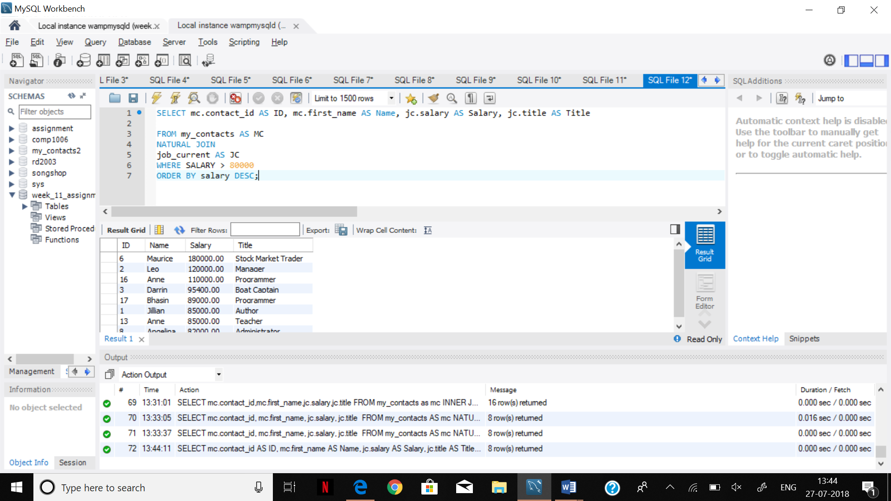

Step 7.

SELECT mc.first_name, mc.last_name, mc.phone, jc.title

FROM job_current AS jc

NATURAL JOIN my_contacts AS mc

WHERE jc.title IN('Chef', 'Hairdresser', 'Waiter', 'manager', 'Web Developer');

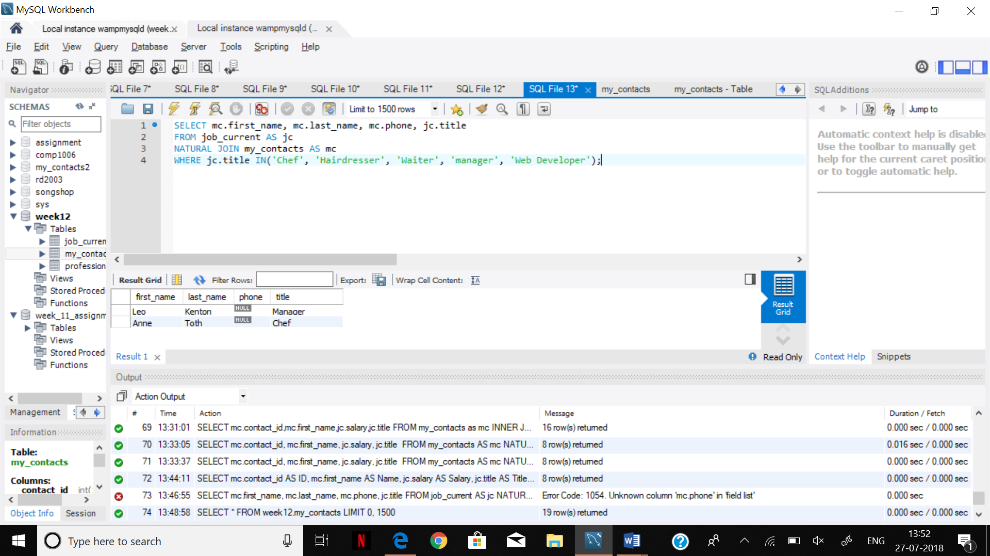

STEP 8.

SELECT ROUND (AVG (Salary))

FROM job_current;

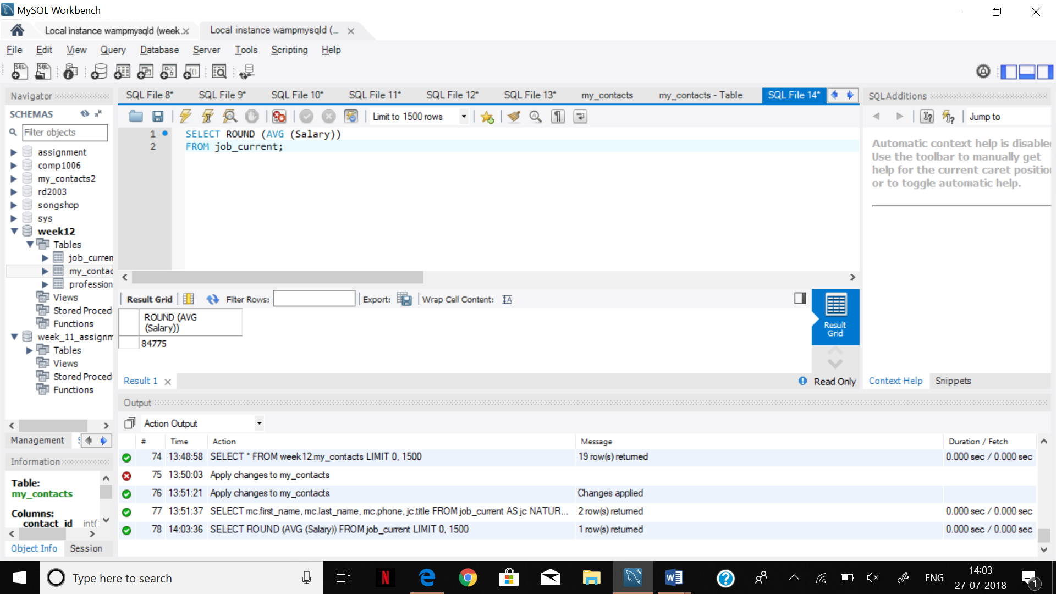

SELECT m.first_name, m.last_name, j.salary, j.title

FROM my_contacts AS m

INNER JOIN

Job_current AS j

ON m.contact_id = j.contact_ID;

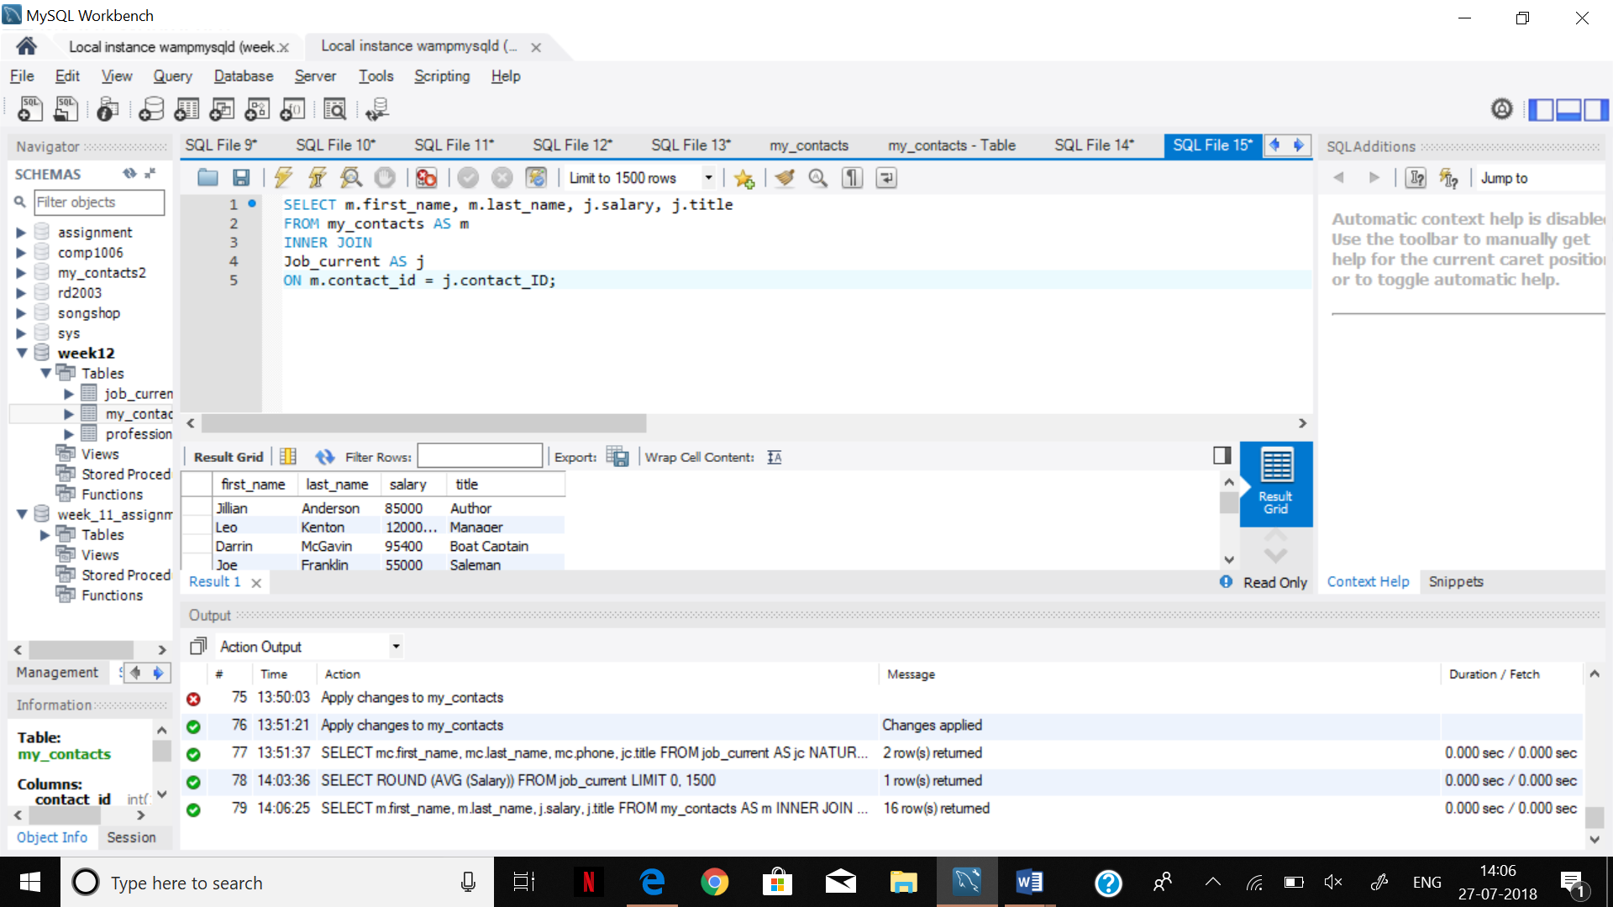

SELECT m.contact_id,m.first_name,m.last_name,j.salary,j.title

FROM my_contacts AS m

INNER JOIN

job_current AS j

ON m.contact_id = j.contact_ID

WHERE salary>=

( SELECT ROUND(AVG(salary))

FROM job_current

);

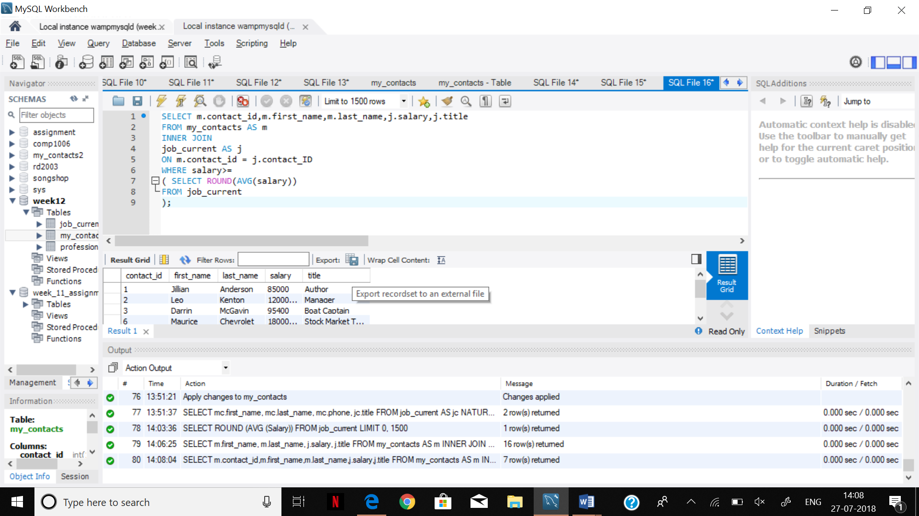

STEP 9.

SELECT m.contact_id,m.first_name,m.last_name,j.salary,j.title

FROM my_contacts AS m

INNER JOIN

job_current AS j

ON m.contact_id = j.contact_ID

WHERE salary <=

( SELECT ROUND(AVG(salary)-10000)

FROM job_current

);

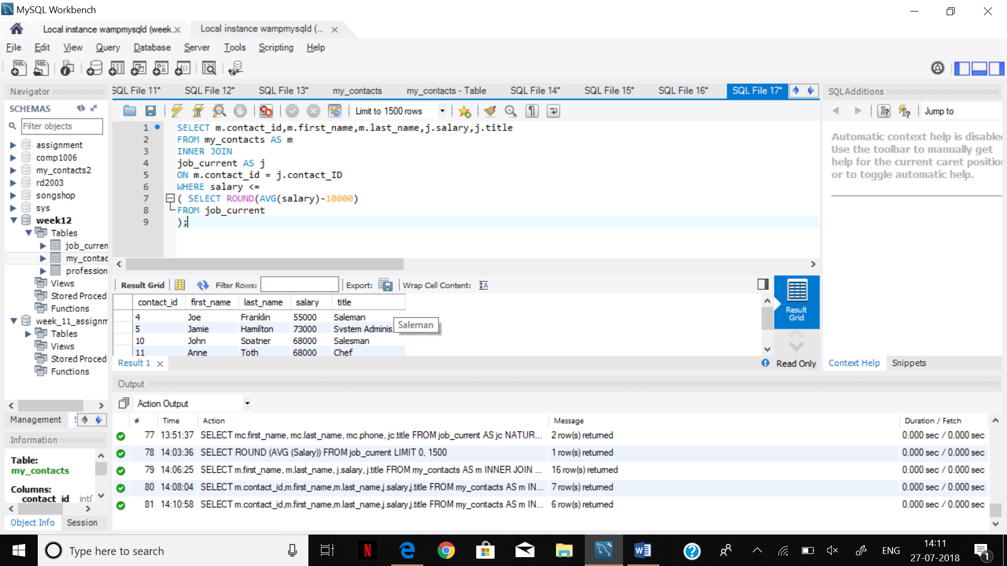

STEP 10.

SELECT j.salary AS Salary,(

SELECT CONCAT(m.first_name,'', m.last_name)

FROM my_contacts AS m

WHERE j.contact_id = m.contact_id)

AS Full_Name

FROM job_current AS j

ORDER BY j.salary DESC;

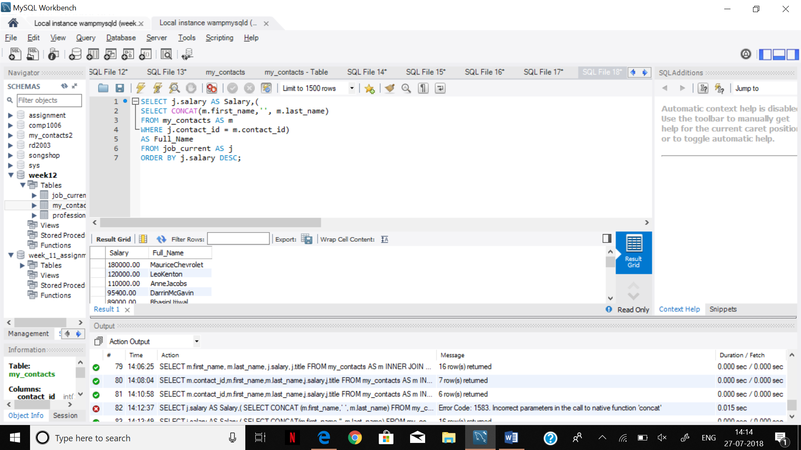

STEP 11.

SELECT salary FROM ( SELECT salary FROM job_current

ORDER by salary DESC

LIMIT 5) AS r

ORDER BY salary LIMIT 1;

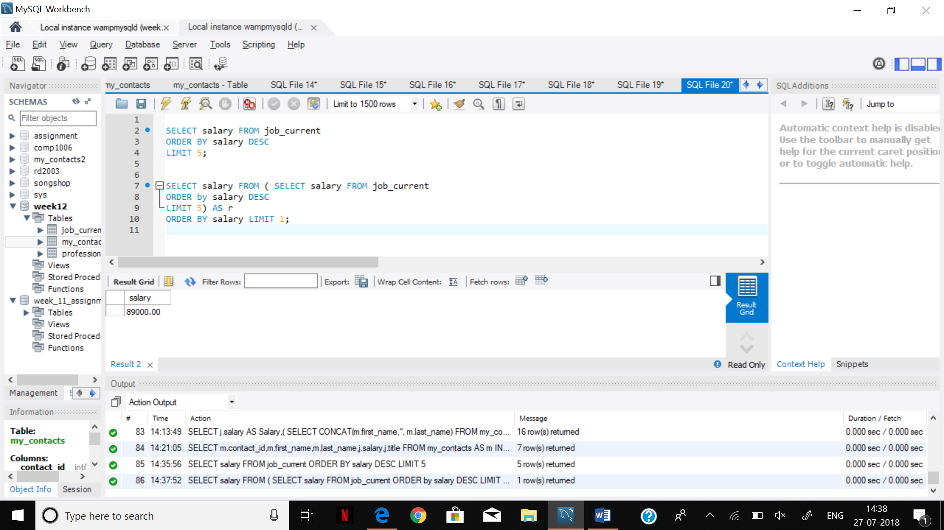

STEP 12.

SELECT ROUND(AVG(j.salary))

FROM my_contacts AS m

INNER JOIN job_current AS j

ON m.contact_id = j.contact_ID

WHERE salary >

( SELECT ROUND(AVG(salary))

FROM job_current

) ;

